Project Plan

Key Objectives

- Constrain how well gyrochronology works empirically for M dwarfs (i.e. what is the typical uncertainty in a rotation-based age estimate?)
- How well can we model the bimodal spindown behaviour of M dwarfs? What does the mass dependence of this behaviour tell us?
  - Is there evidence of an abrupt change in behaviour between partially and fully convective M dwarfs?
- Can we calibrate a model to older ages using wide M-WD and M-FGK binaries?
  - This requires determining whether wide binaries do follow single-star spindown or whether their behaviour is inherently different.
- [STRETCH] Can we infer anything about the evolutionary tracks of individual stars for the population-level behaviour?
- [EXTRA STRETCH!] Can we empirically derive a non-parametric expression for magnetic field complexity (n) as a function of Rossby number (Ro) for M dwarfs, analogous to the Garraffo analytical parameterization:
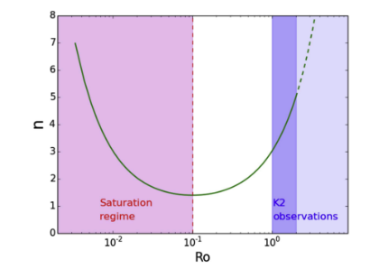

Data

Age-calibrated M dwarfs

- ChronoFlow
  - Ages from open clusters
- Pass et al. (2022)
  - Ages from M-FGK binaries (re-calibrate using ChronoFlow!) and M-WD binaries
- MOCAdb
  - Todo: Phil to provide query criteria
  - Ages by associations (clusters, moving groups)
- Feinstein et al. (2024)
  - Ages by association
- Engle & Guinan (2023), Engle (2023): Living with a Red Dwarf
  - Ages by association and WD binaries
- Mamonova et al. (2025)
  - Ages by association (young moving groups)
- Kiman et al. (2021)
  - Ages by association
- Rebassa-Mansergas et al. (2013)
  - Wide WD binaries

Analysis

- Crossmatch all data to Gaia DR3
  - https://simbad.u-strasbg.fr/simbad/sim-fbasic can be used to crosscheck names
  - ~5 arcsec radius is a good starting point
  - May need to propagate proper motions

- Characterize wide binary systems from Pass/Engle/Rebassa-Mansergas
  - Remove any systems specifically highlighted as triple or higher order systems (which could display peculiar spindown)
  - Determine separation between binary components (these systems should likely be in the El-Badry 2021 Gaia binary catalogue)
  - Record RUWE for each component - if it is high (>=1.2ish), this could indicate a third component - these systems should be flagged

- Test whether binaries in ChronoFlow catalogue (not published) fit single star-spindown
  - Compile the binaries from ChronoFlow sources that were removed from the final catalogue
  - Evaluate the average probabilities for these stars in the ChronoFlow model compared to the average probabilities of stars randomly drawn from the CF model. If they are similar overall (or for specific separations greater than some threshold), this indicates that these stars undergo single-star-like spindown

- Convert observables to theoretical parameters

- Convert colours to masses
  - Convert Gaia photometry to Ks using empirical relations (find source) by crossmatching to 2MASS catalog
    - ChronoFlow (and other datasets) should be filtered to the range of Ks magnitudes that fit the Mann 2019 relationship
  - Make sure de-reddening is properly applied
  - Use MKs - Mass-luminosity (Ks) relationship from Mann et al. (2019)
    - Are there stars that are outside of the valid range for this relationship?
- Use masses to estimate convective turnover time for stars based on empirical relation from Gossage et al. (2024):
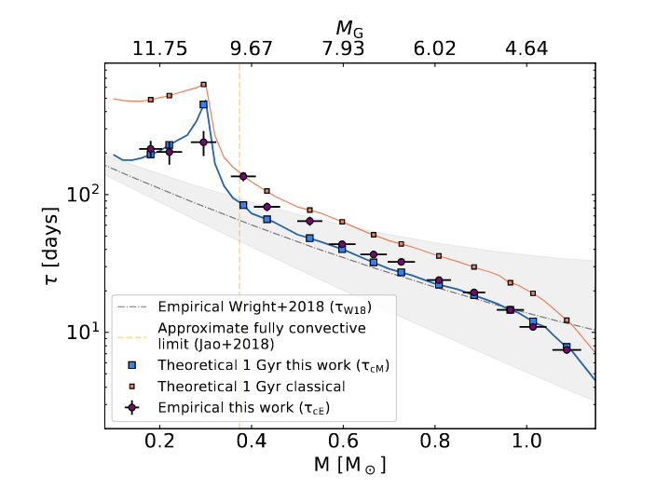
- Use rotation period and convective turnover time to estimate Rossby number

- Develop ChronoFlow analogs that use Mass or Rossby number instead of observed colour.

- Update ChronoFlow to use age uncertainties when training.

- Train new model.

- Analyze probability density distributions

Results

- A ChronoFlow analogue with additional M dwarf calibration, which uses M/Ro instead of colour, and includes age uncertainty
- Characterization of bimodality
- [STRETCH] Evolutionary tracks for M dwarfs

Tests

- Validation tests of training sample
- If we apply this prescription to field rotators, do our age estimates agree with the expected Galactic population distribution?
- E.g. how well are the components of the wide M-M coeval binaries from Pass et al. (2022) aligned?

